Methods.
Describe the model.
A. Exact solution for position of mutator:
Definitions:
Tv Transversion
Ts Transition
V_{n} Maximum number of transversions (5 in our example))
T_{n} Maximum number of transitions (42 in our example)
S_{i} Position in the sequence (i=1,2,3….(V_{n} + T_{n}))
P_{TV} Fractional probability of choosing a Tv (transversion) assuming that both Tv and Ts are available (ie., the number of T_{v} chosen till that point is < V_{n} and the number of Ts chosen to that point is < Tn). This is the initial probability of choosing a transversion at position 1. (in our example this is 0.5)
P_{Ts} Fractional probability of choosing a Ts (transition) assuming that both Ts and Tv are available (ie., the number of T_{v} chosen till that point is < V_{n} and the number of Ts chosen to that point is < Tn). This is the initial probability of choosing a transition at position 1. (in our example this is 0.5)
Note P_{Ts} + P_{Ts} = 1.0
P_{M} Probability of choosing the mutator if a transversion is selected. This is equal to 1/V_{n}.
P_{ATV} is the probability that a transversion is still available at step S_{i} Note to RGP: try and define this a bit more precisely
P_{ATS} is the probability that a transition is still available at step S_{i} Note to RGP: try and define this a bit more precisely

P_{ATV} = EQUATION 1.
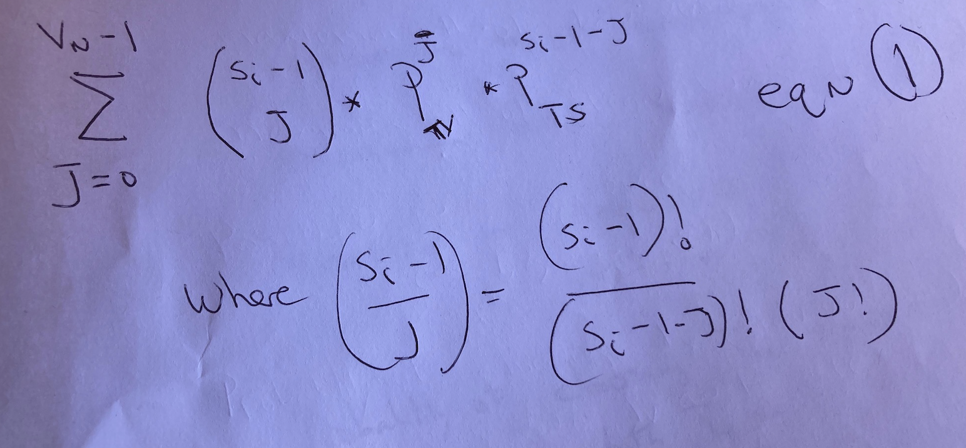
$$\sum_{J=0}^{V_{N}-1}{\left({S_{i}-1 \atop J}\right) x P_{TV }^{J} x P_{TS}^{S_{i}-1-J} }$$
$$Where \left({S_{i}-1 \atop J}\right)= \frac{\left(S_{i}-1\right)!}{\left(S_{i}-1-J\right)!(J!)}$$

P_{ATS} = EQUATION 2.
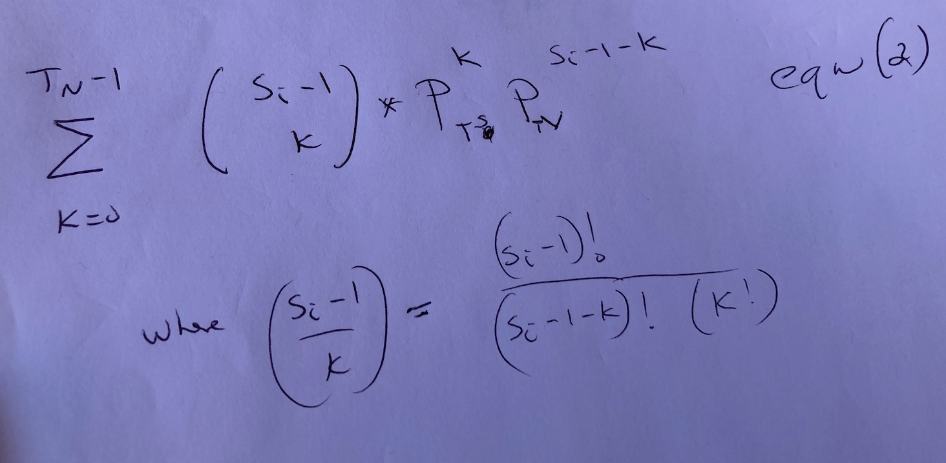
$$\sum_{K=0}^{T_{N}-1}{\left({S_{i}-1 \atop K}\right) x P_{TS}^{K} x P_{TV}^{S_{i}-1-K}}$$
$$Where \left({S_{i}-1 \atop K}\right)= \frac{\left(S_{i}-1\right)!}{\left(S_{i}-1-K\right)!(K!)}$$

The probability of choosing the mutator at position S_{i} is given by:

P_{M} * ((P_{TV} * P_{ATV})+(P_{TS} * (1-P_{ATS})))

Note: In our example, P_{M} = 1/5, P_{TV} and P_{TS} are equal to 0.5. PATV is given by equation 1 and PATS is given by equation 2. a
A script to calculate the mutator probability at any position (S_{i} ) for all values of V_{n}, T_{n}, P_{TV}, P_{TS} is given in Appendix A…. (Ely needs to write this)

B. Stochastic simulation for the problem: In appendix B, we present a scripts to simulate the probability distribution for the position of the mutator. For a large number of samples, the solution is identical to that of the exact solution in A. However, we can also use these scripts to calculate the distribution for transitions and transversions where PTV (and PTS) change after the Mutator is chosen. This is will not alter the distribution of mutator positional probabilities but will alter the distribution of both Ts and TV.
ELY: has already written this script.

Results
The mutS event was early on the AHA branch.
The isolation of the Army Hall A lineage from nature and its adaption to the laboratory is defined by 47 branch SNPs. Because this is a nodeless branch, the sequential order of these mutations is unknown, though understanding when the mutS event occur would provide insights into the adaptive progression. The mutS event is perhaps unique in that its occurrence will change the nature of the subsequent phylogenetic characters, highly biased towards Transitions mutations. Based upon the passage experiments (Table 1), the Ts/Tv ratio will be ~50/50 before the mutS event, and ~95:5 after. Of the 47 AHA branch SNPs, 42 are due to transitions (89%) and only 5 are transversions, which suggests that the mutS event must have happened early in the sequence of mutations. In order to formalize this intuition, we constructed a Monte Carlo simulation based upon a game of chance.

The probabilistic likelihood of the mutS event occurrence at any of the 47 mutations steps on the AHA branch can be reduced to two chance events: What is the probability of any transversion event followed by the probability of the mutS transversion versus the other four AHA branch transversions? While the mutS probability at the first step is easily calculated as 10% (0.5 x 0.2), the subsequent step probabilities are influenced by all of prior sequential steps, which must be included in the model. Our Monte Carlo simulation included the changing priors and generated a probability distribution across the entire 47 mutational sequence (Figure 4). The model predicts the mutS event has a 10% probability at each of the first 5 steps with declining probabilities thereafter. The cumulative probability passes 50% after the 5 step and exceeds 95% probability by step 13. While the mutS probability is never zero, its likelihood in later steps is vanishingly small. Of all the adaptive changes during the domestication of the AHA, the mutS is likely the one that generated the others and then hitchhiked with the adaptive ones.

